International Student Conference On Global Citizenship
SUSTAINABLE RURAL DEVELOPMENT
“Moving Towards Inclusive Growth for All”
17 – 25 January 2016
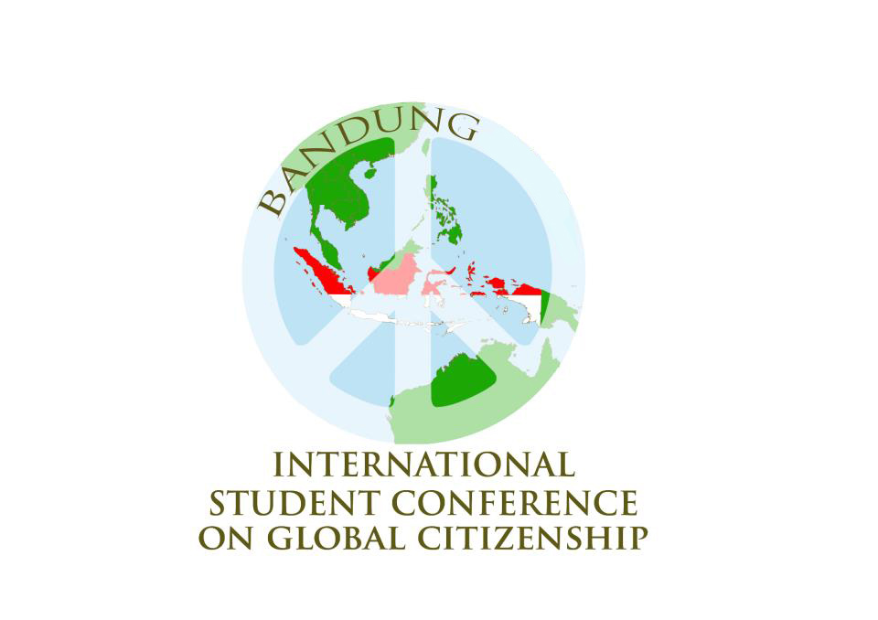
APPLICATION FORM
Deadline – 15 November 2015 at 11.59 P.M. (GMT+7 – Jakarta/Thailand)
Submit your registration form to isc.unpar.2016@gmail.com
E-mail Subject: Your full name (as in passport)_Your University_Your Country
Your picture

Hi, I am .......
Representing....... University
From the beautiful country of ....

Personal Identity

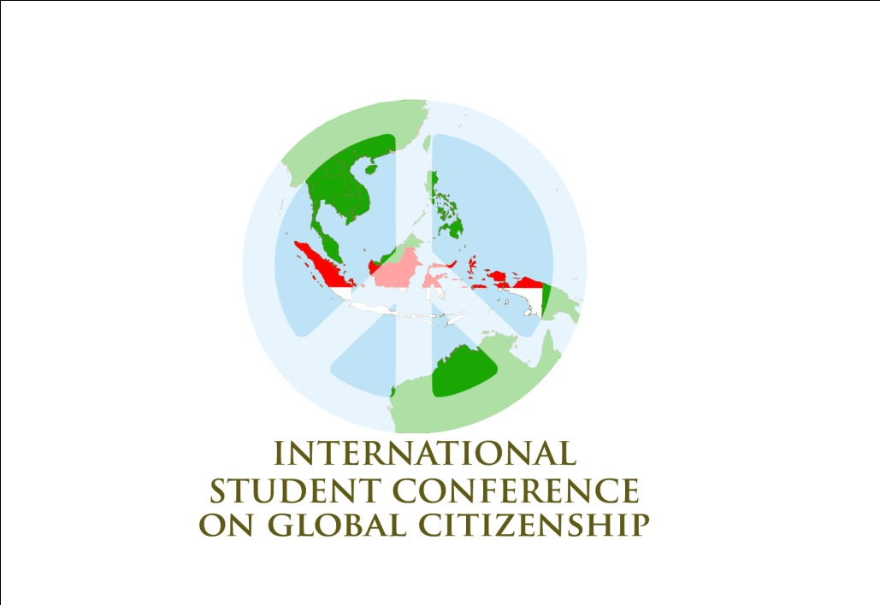
Full name (as in Your Passport):
Place, Date of Birth (DD/MM/YYY) :
Sexuality:
Address :
E-mail:
Facebook:
Twitter:
Phone Number:
Mobile:
Email address of a person who must be contact in case of emergency:
Special Dietary Requirement :
T’Shirt Size:
or Others :

Passport Detail

Surname:
Given Name:
Nationality:
Date of Birth:
Place of Birth:
Passport Number:
Date of Issue:
Date of Expiry :
Issuing Office :
COPY OF YOUR PASSPORT (ENCLOSED):

Education Background

University:
Faculty:
Major:
Class Year:
Current Semester:
GPA:

Virtual Interview
Please answer these questions below :

- What does sustainable rural mean to you? Please describe how horrible is the impact of a poor rural development to the community? And how does your community cope with this problem? (In max 500 words)

- Write down your opinion about what could you do as a student to contribute to create an inclusive growth in rural area?(In max 250 words)

- Do you think that sustainable rural development and inclusive growth are global problems? Please give your reasonable argument about it. (In max 250 words)

- Tell us your motivation participating in International Students Conference on Global Citizenship 2016 in 250 words.

